Genesis

Five-axis milling turning series

Detailed specification configuration

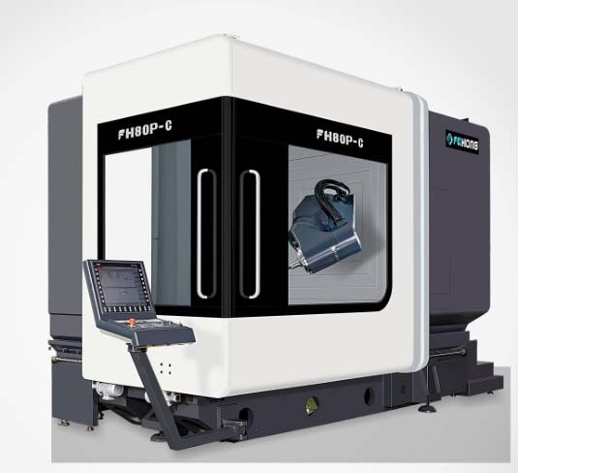

**FH80P‐C**

5-axis milling-turning machining center

XYZ linear axis hollow cooling screw drive

B\C Rotary axis DD direct drive transmission

Fully closed-loop absolute measurement system

Guangdong Genesis Intelligent Equipment Group Co.



1 Scope of supply

Standard accessory menu

Standard accessory menu (please refer to the controller function for the electric control part)

Genesis FH80P-C 5-axis milling-turning machining center configuration

1. Siemens 840DSL controller

2. Genesis five-axis multifunctional pendulum head

3. Electric spindle DGZX-24012/34B2-KFHWVJS

4. HSK-A63 40 tool changer with automatic tool change system

5. X/Y/Z hollow cooling ball screw drive

6. 7 roller linear slides (3 for X-axis, 2 for Y/Z-axis)-BOSCH REXROTH

7. X/Y/Z three-axis fully closed-loop optical scale

8. Electrical box temperature control device

9. Spindle cooler

10. Spiral chip winding device and rear chip conveyor with chip carriage

11. Spindle center water outlet, circular water spray

12. Spindle center air blowing, ring air blowing.

13. Five-axis head crescent blowing water, crescent blowing air.

14. 1 type of safety interlock for front and side working door

15. Spindle circulation cooling device.

16. Waterproof working daylight

17. Hydraulic station unit

18. Renishaw OMP60 infrared probe unit

19. Renishaw laser tool setter unit

20. Centralised automatic feed lubrication unit

21. Operator side clean water gun and air connection

22. Cutting fluid cooling system

23. Fully enclosed protective sheet metal

24. Operation box

25. Electrical box equipped with air cooler

26. Siemens electronic hand wheel

27. Foot-operated spindle release switch

28. Foundation level spacer and foundation bolt

29. Adjustment tools and tool box

30. Technical manual

# Basic specifications of the machine



2

|  |  |  |  |  |
| --- | --- | --- | --- | --- |
| 规格/机型 | Model | | Unit | FH80P-C |
| travel | | | | |
| X 轴行程 | X axis travel | | mm | 800 |
| Y 轴行程 | Y axis travel | | mm | 1050 |
| Z 轴行程 | Z axis travel | | mm | 800 |
| 主轴端面至工作台距离 | Distance from spindle nose to work table surface | | mm | 162-962 |
| 卧式铣头 | Horizontal milling head | | mm | 39-839 |
| 进给/快移速度 | Feed/fast moving speed | | m/min | 40 |
| 进给力 | Feed force | | KN | 10 |
| Rotary table (C-axis) | | | | |
| 工作台尺寸 | Working table size | mm | | Ø850 |
| 最大工作台承重 | Max.table load (mill) | kg | | 3000 |
| Max.table load (turning) | kg | | 1500 |
| 数控回转工作台 | Rotray table | rpm | | 40 |
| 铣/车工作台（铣车复  合加工） | Milling/turning woking table  (compound milling and turning) | rpm | | 550 |
| 最小分割角度 | Minimum division angle | ° | | 0.001 |

|  |  |  |  |
| --- | --- | --- | --- |
| 规格/机型 | Model | Unit | FH80P-C |
| 额定扭矩 | Rated Torque | Nm | 1140 |
| 最大扭矩 | Maximum Torque | Nm | 1980 |
| CNC pendulum milling head (B-axis) | | | |
| 摆动范围(0=垂直/180=水平) | Swing range(0=Vertical/180=Level) | ° | -15～180 |
| 快移速度及进给速度 | Fast moving and feeding speed | rpm | 80 |
| 最小分割角度 | Min. splitting angle | ° | 0.001 |
| 额定扭矩 | Rated Torque | Nm | 743 |
| 最大扭矩 | Max. torque | Nm | 1320 |
| Spindle (Milling and turning) | | | |
| 主轴转速 | Spindle speed | rpm | 12000 |
| 主轴功率（S1/S6） | Spindle power(S1/S6) | Kw | 34/42 |
| 主轴扭矩（S1/S6） | Spindle torque(S1/S6) | Nm | 132/185 |
| 主轴锥孔 | Spindle tapre |  | HSKA63 |
| 主轴中心至横梁导轨面距离 | Distance from spindle center to beam guideway surface | mm | 1064.5 |

|  |  |  |  |
| --- | --- | --- | --- |
| 规格/机型 | Model | Unit | FH80P-C |
| Tool magazine | | | |
| 刀具接口 | Tool interface |  | HSKA63 |
| 刀库容量 | Tool magazine capacity | PCS | 40 |
| 最大刀具直径/长度/重量 | Max. tool diameter/length/weight |  | Ø85/300/8 |
| 换刀时间(刀对刀) | Tool change time (tool to tool) | S | 1.8 |
| Measuring devices | | | |
| 红外线测头 | Infrared probe | Rensishaw OMP60 | |
| 加工区内刀具测量 | Tool detection instrument in  working processing area |  | Rensishaw  NC4F230 |
| Processing capacity | | | |
| 钻孔（正火中碳钢） | Max. drilling diameter(Medium steel) |  | Ø40 |
| 攻丝（正火中碳钢） | Max. tapping diameter(Medium steel) |  | M24 |
| 铣削（正火中碳钢） | Max. milling diameter(Medium steel) |  | 250 |
| Position accuracy (ISO230-2 a n d VDI3441) | | | |
| X/Y/Z 定位精度 | X/Y/Z positioning accuracy | mm | 0.005 |
| X/Y/Z 重复定位精度 | X/Y/Z Repeat positioning accuracy | mm | 0.004 |
| B/C 定位精度 | B/C positioning accuracy |  | 8" |
| B/C 重复定位精度 | B/C Repeat positioning accuracy |  | 4" |

|  |  |  |  |
| --- | --- | --- | --- |
| 规格/机型 | Model | Unit | FH80P-C |
| Controller | | | |
| 数控系统 | Control system |  | Siemens840D |
| Other | | | |
| 机床高度（标配机床） | Machine height(General machine) | mm | 3350 |
| 主机占地面积(长x 宽) | Occupied area for main machine(L*W) | mm | 4800x2930 |
| 刀库占地面积(长x 宽) | Occupied area for tool magazine(L*W) | mm | 2100x1250 |
| 排屑器占地面积(长 x 宽) | Occupied area for chip conveyor(L*W) | mm | 3070x1065 |
| 水箱占地面积(长x 宽) | Occupied area for water tank(L*W) | mm | 1785x1355 |
| 机器总占地面积（不  含水箱）(长 x 宽) | Grand total occupied area to complete machine(L*W) | mm | 5610x3600 |
| 机床重量 | Machine weight | Kg | 18500 |

External dimensional drawing FH80P-C model

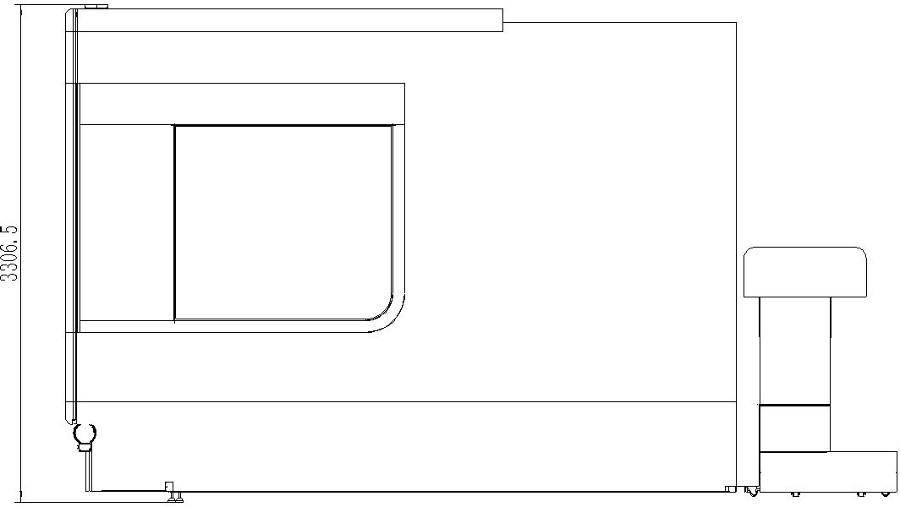

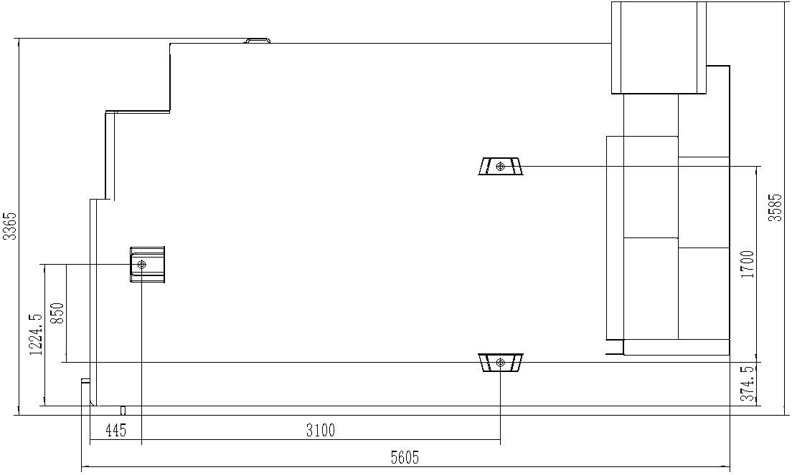

# Machine tool CNC



3

|  |  |  |  |
| --- | --- | --- | --- |
| Control system | Siemens 840DSL (motors and drives) | | |
| Number of control axes | 5-axis simultaneous milling with simultaneous turning (NC axis + spindle, BC axis) | | |
| Number of simultaneously controlled axes 5 axes simultaneous milling with turning | Positioning axes | Standard X, Y, Z, B, C | |
| Interpolation | Straight line | X, Y, Z, B, C axis (X, Y, Z, B, C can be compensated) |
| Circular arc | X, Y, Z, B, C axis (X, Y, Z, B, C can do compensation) |
| Minimum command unit | 0.001um | | |
| Minimum control unit | 0.1nm | | |
| Display | 19LCD | | |
| Motor | Triple overload capability with absolute encoder (encoder position never lost) | | |
| External communication function | Ethernet and RS232C interface | | |
| Operation method | MDI, automatic, manual, handwheel, return to home (absolute), REPOS | | |
| Programming method | Online ISO Language Editor | | |
| Maximum PLC programming memory capacity | 2048KB | | |
| Interpolation function | Straight lines, circles past center point and center point, spirals, fine and excellent surfaces, high speed settings, etc. | | |
| Number of tool compensation | 512 groups | | |
| Handwheel multiplier | 0.1/0.01/0.001mm | | |
| Minimum setting and moving units | 1um/X,Y,Z | | |
| Data storage | Memory data is never lost when power is lost | | |
| Feed multiplier | 0%-150% | | |
| Fast forwarding multiplier | 0%-100% | | |
| Input/output interface | Ethernet and RS232C interface, CF card, USB storage backup | | |
| Display Language | Chinese, English | | |



4 Number of standard configurations

|  |  |  |  |
| --- | --- | --- | --- |
| Serial No. | Accessory Name | Unit | Quantity |
| 1 | Foot control switch | Set | 1 |
| 2 | Hydraulic clamping mechanism | Set | 1 |
| 3 | Centralized lubrication device | Set | 1 |
| 4 | Cooling system | Set | 1 |
| 5 | Working light | Set | 1 |
| 6 | Three-color light | Set | 1 |
| 7 | Horizontal bridge plate | Set | 1 |
| 8 | Machine tool fixings | set | 1 |
| 9 | Standard tool kit | set | 1 |
| 10 | Safety door locks | set | 1 |
| 11 | Foundation kit | set | 1 |
| 12 | Random installation and adjustment tools | set | 1 |
| 13 | Rigid tapping and spindle multi-point positioning | Set | 1 |
| 14 | Screw chip conveyor and automatic chip evacuator | Set | 1 |
| 15 | Standard hydraulic system | Set | 1 |

Key outsourced components configuration table



5

|  |  |  |  |
| --- | --- | --- | --- |
| Name of main accessories | Place of origin | Brands | Remarks |
| CNC system | Germany | Siemens | Siemens 840DSL |
| Main axis motor | China | Haozhi |  |
| X、Y、Z axis servo motor | Germany | Siemens |  |
| Spindle | Joint Venture | FEIHONG | Adopt German FAG bearing |
| Spindle bearing | Germany | FAG |  |
| Screw bearings | Germany | FAG |  |
| Linear guide | Germany | Rexroth | UP grade precision |
| Ball Screws | Taiwan | HIWIN | C3 grinding grade |
| Hydraulic components | China | FEIHONG |  |
| Automatic lubrication system | China | Proton |  |
| Cooling System | China | FEIHONG |  |
| Lighting system | China | EUN |  |
| Alarm light | China | OUEN |  |
| Electrical | France / Germany | Schneider / Siemens |  |
| Drag chain protection | China | Junhong |  |
| Control wire cable | Germany | Leipu Nanni |  |

# A brief description of machine performance



6

Main machine technical specifications | optimal rigid structure configuration

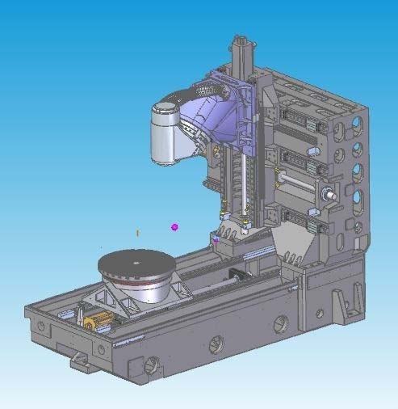

Design Features | Best Mechanical Line Casting Analysis Design

* Fully boxed, thermally symmetrical casting structure with Meehaner grade high-grade cast iron
* Tempered with natural aging treatment to eliminate internal stresses
* Structure natural frequency vibration to eliminate material processing stress
* Full wall large area high rigidity column design, effectively enhance the rigidity and static and dynamic accuracy
* Three-axis hollow cooling screw drive

## CNC pendulum milling head (B-axis)

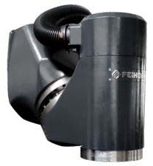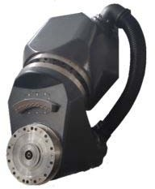

**Design Features**

* Built-in DD motor with zero drive chain and no backlash design
* High acceleration characteristics
* Shortest spindle tip point and structural support point span for maximum cutting rigidity
* Large YRT bearings for increased rigidity
* Heidenhain high-precision rotary encoder measurement system with full closed-loop control to ensure the best accuracy
* Spindle and B-axis cooling system design to reduce heat transfer

## **Rotary table (C-axis)**

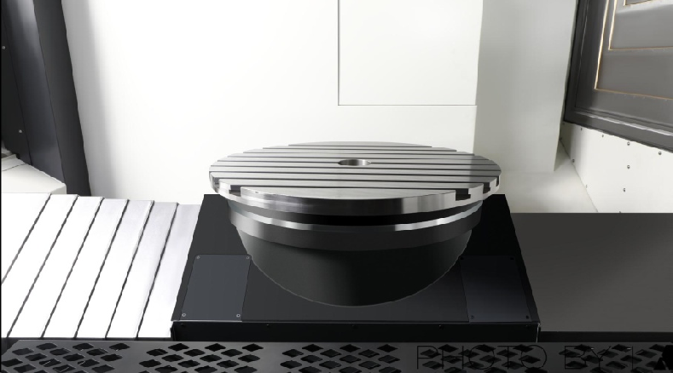

**Design Features**

* Built-in DD motor with zero drive chain and no backlash design
* High acceleration and deceleration response characteristics
* Large YRT bearing for improved rigidity
* High rated drive torque, positioning machining with table positioning clamping device
* Meet both milling and milling-turning machining requirements, reduce workpiece handling and improve product accuracy
* Equipped with Heidenhain high-precision rotary encoder measurement system, fully closed-loop control to ensure the best accuracy
* Cooling system design to reduce heat transfer

## **Liftable tool setting instrument**

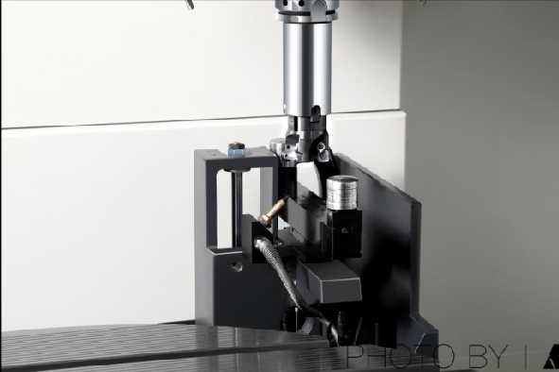

**Design features**

* Equipped with Ransishaw NC4F230 non-contact laser tool setter for greater precision
* On-machine automatic tool setting and automatic tool compensation update
* Liftable tool setting device to save space on the machining surface
* Fully sealed sheet metal design protects the tool setter from water and swarf damage during machining

## **Infrared probe**

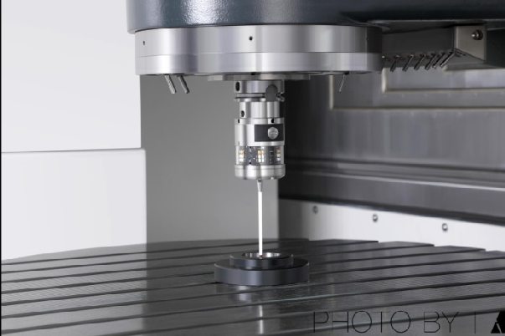

**Design features**

* Equipped with Ransishaw OMP60 touch-trigger optical probe
* On-machine work piece set-up and dimensional inspection, reducing manual inspection errors and improving product accuracy and machining efficiency
* 90% savings in on-machine assistance time

## **Safety protection sheet metal**

**Exterior**

The FH series five-axis milling-turning machining center is designed to meet strict CE safety standards, with fully enclosed sheet metal to prevent operators from accidentally entering the work area during machining, and to prevent the use of high-pressure cutting fluid or chips from being ejected from the machine, and in addition to the warning nameplate, the operator door is also equipped with a safety switch to prevent accidents during operation or maintenance. It also has a large peephole for the operator to understand the operation of the machine.

## **Cleaning**

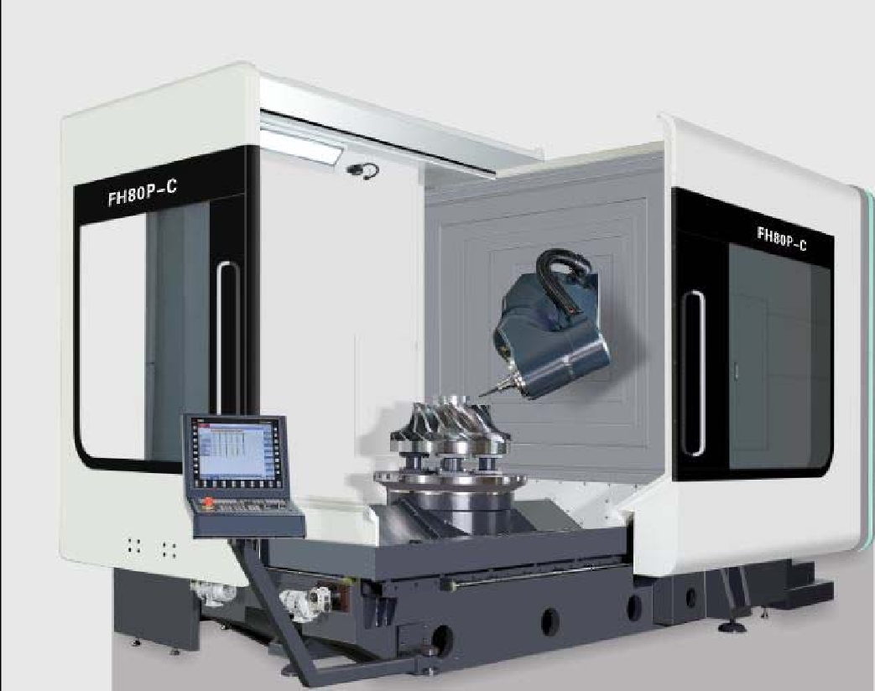Protects chips generated during operation with telescopic shields and protective sheet metal to avoid damage to other mechanisms caused by cutting splashes

**Lighting**

The work area is equipped with two LED lamps, and the illumination level is maintained at 800LUX or more, providing the operator with a proper bright working environment.

**Operability**

The sliding door on the operating side provides a large opening space for easy loading and unloading of workpieces from three directions using the overhead crane.



7



7



7



7

# Technical Information

1、Operation manual (including electrical operation manual, electrical schematic diagram, electrical alarm codes, etc.) 1 copy

2、Maintenance manual 1 copy

3、Maintenance manual 1 copy

4、The parameters of the manual 1 copy

5、Machine certificate of conformity 1 copy

6、Machine parameter backup 1 copy



8 Environmental standards and related requirements for the installation and use of machine tools

1、Environmental parameters

|  |  |  |
| --- | --- | --- |
| Item | Environmental parameters conditions | Remarks |
| Temperature | 17℃～25℃（during operation) | Allowable range 15℃～40℃  Ideal operating environment temperature ±2℃ |
| 0℃～60℃（during transportation) |
| Humidity | At 20℃ 40%～70% | No condensation |
| Vibration | Below 0.5G |  |

2、Installation site

* Do not install the machine in radiation, such as: microwave, ultraviolet, laser or X-rays range.
* To ensure the machining accuracy of the machine and to reduce the temperature difference around the equipment, do not install in the following areas:

a) direct sunlight b) high humidity c) high temperature difference d) vibration e) strong magnetic fields f) dusty

* Avoid the following conditions around the installation area of the equipment:

a) Garage

b) lanes with frequent car traffic

c) pressure or stamping equipment

d) welding, spot welding or hydrogen arc welding

e) substations

f) high voltage lines

g) dust-prone equipment or processing

3、Installation site requirements

* The foundation of the equipment installation site, must be all compacted. There is no hollow, false earth and other poor foundations.
* Equipment installation site must have a fixed power supply in line with the relevant national requirements, do not use temporary power supply, must ensure that the equipment has good grounding protection.
* The installation site of the equipment must be a stable source of air, the compressed air provided must be dry, clean compressed air in line with the relevant national requirements.

4、Installation site requirements

* Power supply interface: The power supply provided by the equipment installation site must be three-phase four-wire system, the power line voltage is 380V, pay attention to the voltage regulation of the power supply, be sure to ensure that the power supply voltage fluctuations must not be higher than ± 5%. If the three-phase four-wire power line voltage provided by the equipment site is 220V±5%. Equipment in the power electric access, do not connect through the transformer.
* Compressed air interface: p = 4 ~ 6kgf / cm², Q = 5m³ / h, air source interface reserved ￠ 10 quick connector, connector knife equipment installation location, reserved ￠ 10 ~ m, so that the site for temporary adjustments. The main line of compressed air must be equipped with a main line filter, drier. Air pressure must be guaranteed at 0.5 ~ 0.7Mpa.

5、Party A shall reserve sufficient installation space according to the machine dimensions of the equipment sample provided by Party B to facilitate the positioning and maintenance of the machine.

6、Party B is responsible for the installation and commissioning of the equipment free of charge, and the installation of the equipment in place at the installation is the responsibility of Party A.



9 Receiving and inspection

* Party A to accept the technical performance of the equipment:

a) appearance inspection

b) acceptance of the standard specifications of the mechanical body

c) 24-hour operation without load

* Party A check and acceptance according to the above configuration list
* Party A to carry out technical data acceptance